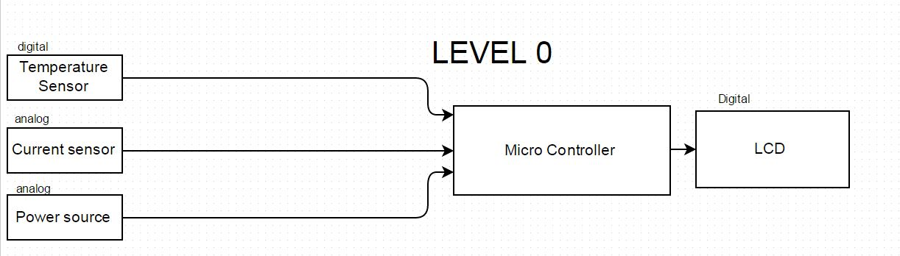

|  |  |
| --- | --- |
| Module | Thermal Monitoring System |
| Input | Analog input signal: 0-5 V DC  Digital input signal: 8-bit I2C protocol  Power: 5V DC |
| Output | 4-bit Digital Signal to LCD |
| Functionality | Monitoring and displaying current and temperature for a bus bar system.  Current range: 0-80 A  Ambient temperature range : -40 to 85°C  Target object temperature range: -70 to 382.2°C |

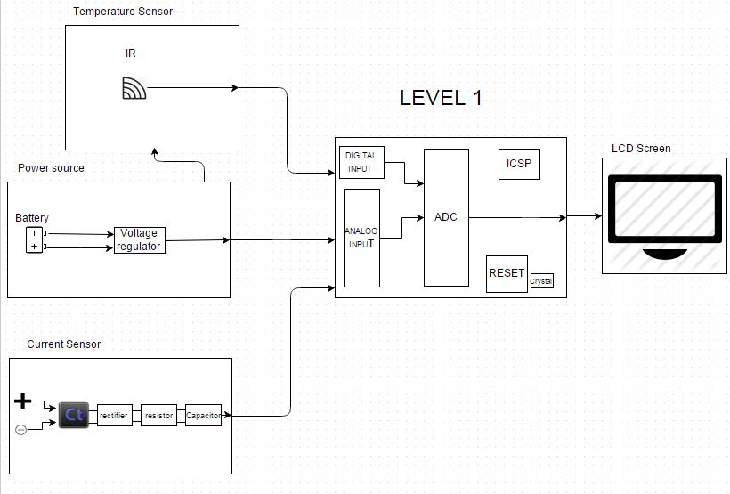

Current Sensor: Level 0

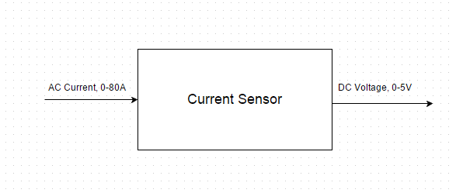

|  |  |
| --- | --- |
| Module | Current sensor |
| Input | Current : 0-80A |
| Output | Voltage: 0-5V DC |
| Functionality | Convert high amperage to lower voltage for analog input of microcontroller |

Power Source: Level 0

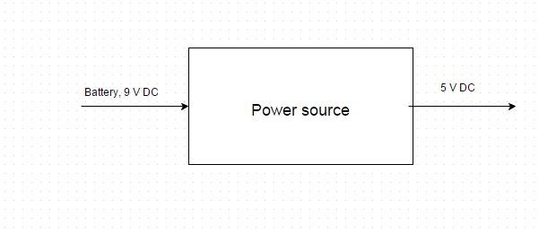

|  |  |
| --- | --- |
| Module | Power source |
| Input | Battery : 9V DC |
| Output | 5V DC |
| Functionality | Regulates Voltage for proper specifications of micro controller. |

Temperature Sensor: Level 0

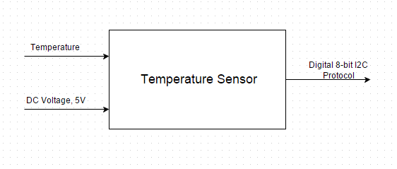

|  |  |
| --- | --- |
| Module | Temperature sensor |
| Input | 5V DC  Temperature: 0-100˚ C |
| Output | 8-bit digital signal (I2C protocol) |
| Functionality | Read temperature from Bus bar for monitoring. |

Microcontroller: Level 0

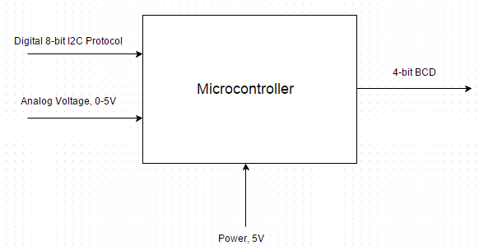

|  |  |
| --- | --- |
| Module | Microcontroller |
| Input | Digital signal: 8 bit (I2C protocol)  Analog signal: 5V DC  Power: 5V DC |
| Output | 4-bit BCD |
| Functionality | Analog to Digital converting  Take input from temperature sensor to convert to BCD using C language coding.  Take input from current sensor to convert to BCD using C language coding. |

LCD: Level 0

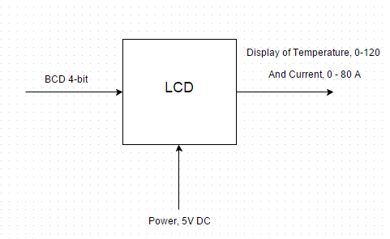

|  |  |
| --- | --- |
| Module | LCD |
| Input | 4-bit BCD  Power: 5V DC |
| Output | Text display |
| Functionality | Display the current and temperature of the system on the screen for monitoring. |

Activity View T07 Thermal Monitoring System

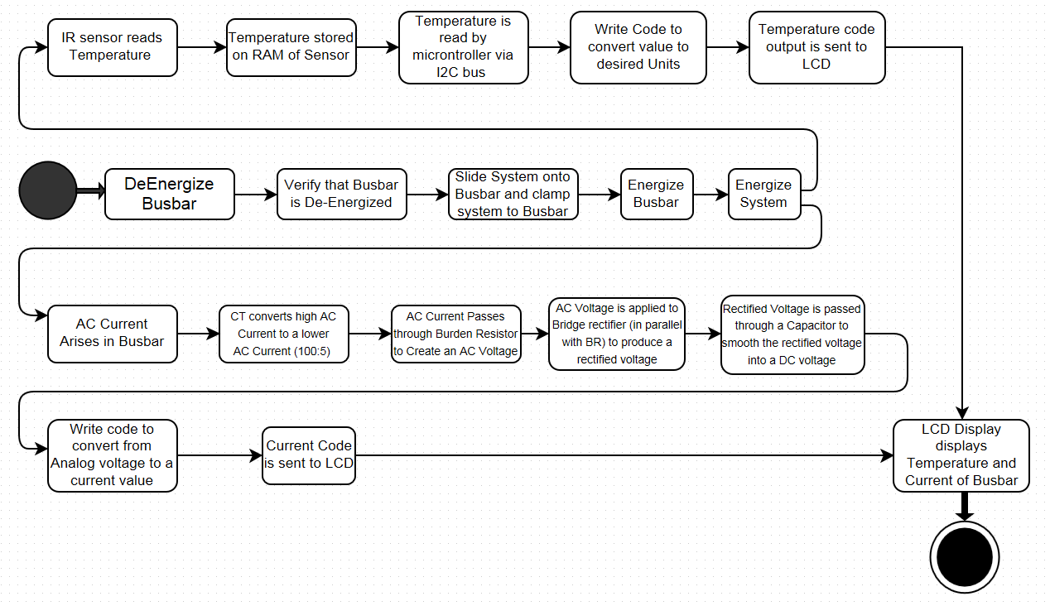

Interaction View T07- Thermal Monitoring System

